**TABLES AND KEYS**

* Tables are used to store information in relational databases.

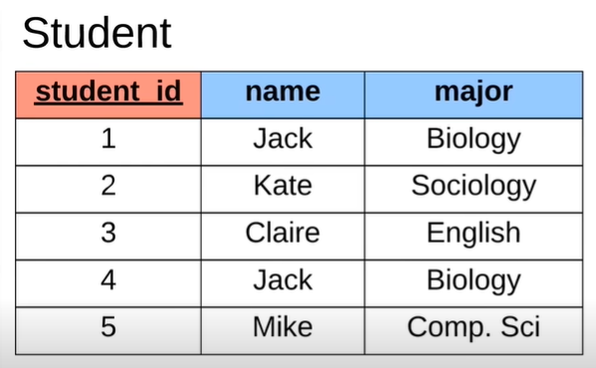

* Student table defines specific information about the students.
* All tables in relational database are going to have two things - columns and rows.

1. Column (vertical section)

* Defines the single attribute
* Column names – student_id, name, major
* This table is storing three pieces of information about each student.

1. Row (Horizontal section)

* Represents the single student.
* In single row, we’re storing the students ID, the name and the major.

**KEYS:**

1. **Primary Key**

* One special column that we want whenever we create table in relational database.
* It is an attribute which uniquely defines the row and differentiate the rows in the databases.
* Primary key can be strings, numbers or anything.
* Ex: student_id column
* The attributes inside this column is the primary key which is used to uniquely identify a specific row.
* Ex: 1.Kate’s primary key is 2.

2. Two Jack in both of which is biology majors and can identify each of them with primary key that is unique for each individual.

**TYPES OF PRIMARY KEYS:**

1. **Surrogate key**

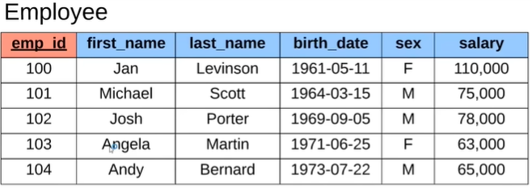

* Key that has no mapping to anything in the real world but only in the databases.
* Ex: emp_id
* Random number that is assigned to the employee.
* Number that doesn’t mean anything. It is just used to represent the employee inside the databases.

1. **Natural key**

* Key that has a mapping or purpose in the real world, not only in the database.
* Examples include Aadhar number which is used to uniquely identify each citizen in India, can be used to uniquely identify each citizen’s information in the databases.

**2. Foreign Key**

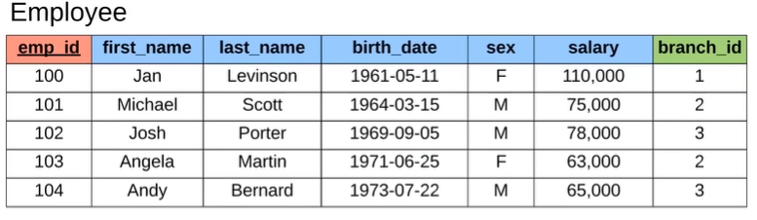

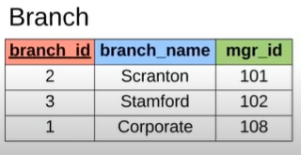

* Attribute that we can store on a database table that will link us to another database table or same database table.

Ex: branch_id of the employee table

* Foreign key stores the primary key of a row of another database table or same database table.

Ex: branch_id of the branch table

* It is just the way to define relationships between the tables or within the table.
* One particular table can have any number of foreign keys as columns.

Another database table

* Ex: Jan Levinson of employee table have branch id ‘1’ which means she belongs to ‘corporate’ branch in the branch table.

(Foreign key - branch_id of the employee table

Primary key - branch_id of the branch table)

* Ex: Branch name ‘Scranton’ have manager id ‘101’ in branch table in which it refers to employee id ‘101’ who is ‘Michael Scott’ in employee table.

(Foreign key – mgr_id of the branch table

Primary key - emp_id of the branch table)

Same database table

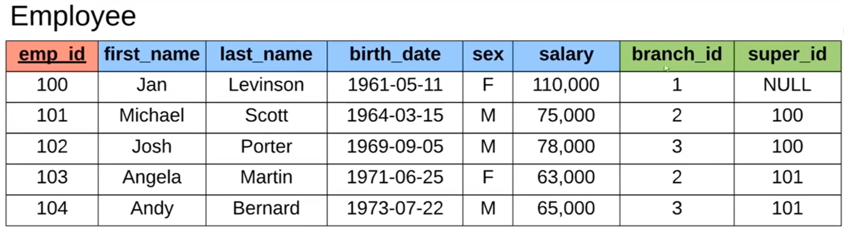

* Ex: Employee id ‘101’ have supervisor id ‘100’ which refers to the employee id ‘100’. Jan Levinson is the supervisor of Michael Scott.

(Foreign key – super_id of the employee table

Primary key - emp_id of the employee table)

1. **Composite key**

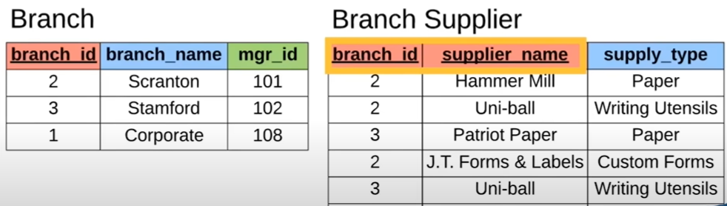

* Primary key consists of two columns called Composite key.
* Key that needs two attributes.
* Each attribute is not enough to uniquely identify the row of the databases.
* Only together, the attributes can uniquely identify the each row.
* Ex: In branch supplier table, each column has repeated values, in which the composite key is used to uniquely identify each rows (defining two columns as a primary key).

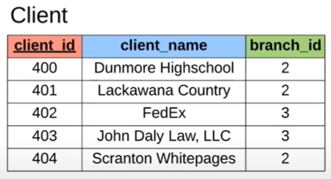

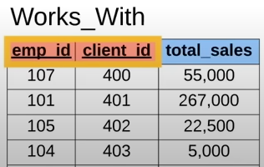

* Both of the emp_id, client_id are foreign keys. Both make the primary key of the table.